Applecross Senior High School
Semester 1 Examination, 2013

Question/Answer Booklet

HUMAN BIOLOGICAL SCIENCE
Stage 3

Student Name
Teacher

Time allowed for this paper
Reading time before commencing work: ten minutes
Working time for paper: three hours

Materials required/recommended for this paper

To be provided by the supervisor
This Question/Short-Answer Booklet
Multiple-choice and Extended Answer Booklet

To be provided by the candidate
Standard items: pens (blue/black preferred), pencils (including coloured), sharpener, correction tape/fluid, eraser, ruler, highlighters

Special items: non-programmable, non-graphics calculators approved for use in the WACE examinations

Important note to candidates
No other items may be taken into the examination room. It is your responsibility to ensure that you do not have any unauthorised notes or other items of a non-personal nature in the examination room. If you have any unauthorised material with you, hand it to the supervisor before reading any further.
Section One: Multiple-choice 30% (30 Marks)

This section has 30 questions. Answer all questions on the Multiple-choice Answer Sheet provided.

For each question shade the box to indicate your answer. Use only a blue or black pen to shade the boxes. If you make a mistake, place a cross through that square, do not erase or use correction fluid, and shade your new answer. Marks will not be deducted for incorrect answers. No marks will be given if more than one answer is completed for any question.

Suggested working time for this section is 40 minutes.
________________________________________________________________________

1. Natural selection is occurring in a population. Which of the following statements is CORRECT?
a) The population must be completely isolated from other groups of the same species.
b) There must be variation amongst the individuals making up the population.
c) Interbreeding must occur with related groups.
d) Mutations must occur frequently within the population.

2. Random Genetic Drift probably played a significant role in the evolution of primitive humans because:
a) breeding groups were small and isolated.
b) selective pressures were greater.
c) they were not as adept at altering their environment as modern man.
d) they mated randomly - not inhibited by the cultural and religious barriers that exist in modern human populations.

3. Four hominid skulls were found in the same excavation site. Under a series of tests the following results were obtained but the data are incomplete. It is known that the oldest bones contain the highest concentration of fluoride and the lowest concentration of carbon 14.
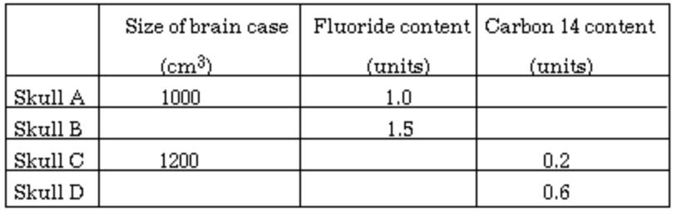

Which skull is probably the oldest ?
a) Skull A. b) Skull B.
c) Skull C. d) Skull D.

4. Potassium-argon dating of volcanic lava would depend upon the fact that:
a) molten lava contains little or no argon.
b) potassium breaks down to calcium as well as argon.
c) the mass of potassium in lava increases as argon decays.
d) at the time of death organisms stop consuming potassium so the quantity of potassium in a fossil shows how long it has been dead.

5. The agricultural revolution accelerated human cultural evolution because it:
a) was a more efficient way of food production than hunter gathering.
b) increased the mobility of people.
c) caused an increase in the world population.
d) occurred independently in three different places around the world.

6. Consider the diagrams below:
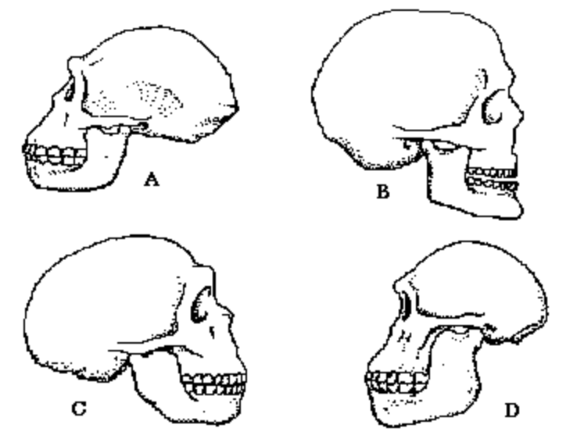

Which of the following would be the most likely evolutionary sequence towards Homo sapiens ?

a) D --> A --> C --> B.
b) A --> B --> C --> C.
c) D --> C --> A --> B.
d) B --> D --> C --> A.

7. Consider the diagrams below of four different stone tools.
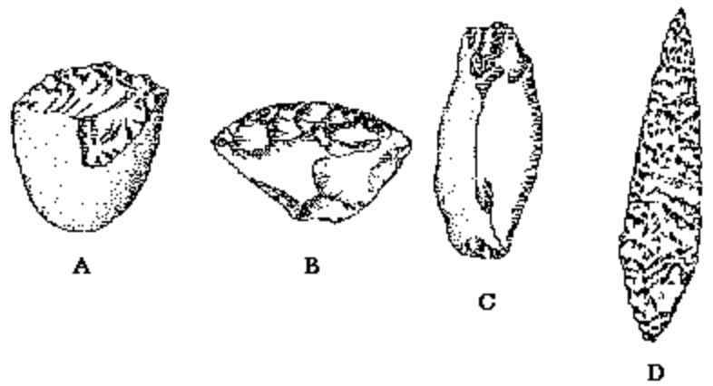

The correct ranking of these stone tools, from least to most advanced, is:

a) A B C D
b) B A D C
c) C B A D
d) A C B D

8. The flow of information in a cell proceeds
a) from RNA to DNA to protein.
b) from protein to RNA to DNA.
c) from RNA to protein to DNA.
d) from DNA to RNA to protein.

9. Your muscle and bone cells are different because
a) they contain different sets of genes.
b) they contain different operons.
c) different genes are switched on and off in each type of cell.
d) they contain different histones

10. In eukaryotes, gene expression is regulated mostly by _____.
a) controlling gene packing and unpacking
b) controlling the transcription of genes
c) controlling the translation of mRNA into protein
d) selectively breaking down certain proteins so they cannot function

11. In a group of organisms, individuals genetically identical at a particular single gene locus show a variety of phenotypes for the trait. It is reasonable to conclude that the variation in phenotypes for this trait is the result of:
a) dominant alleles.
b) polygenic inheritance
c) environmental influences
d) multiple alleles at the locus

12. Cloning a human gene into the plasmids of bacteria has enabled scientists to _____.
a) insert the corrected gene into patients who have certain genetic disorders
b) match DNA found at a crime scene to a suspect's DNA
c) use bacteria as "factories" for protein products
d) identify carriers of genetic diseases

13. In the great plague epidemics of Europe in the fourteenth century, one quarter of the population died. In England, the population fell from 3.8 million to 2.l million in thirty years. 80% of those infected with the plague died. The children of the 20% of survivors grew and intermarried, and a large proportion of their offspring survived attacks of the plague. Within a couple of generations, the numbers of partially or wholly protected people in a population exposed to plague had risen greatly and so the devastating effects of the disease were halted.

This is an example of:
a) blending of races.
b) changing of culture.
c) natural selection.
d) learning from previous generations.

14. Which is the most plausible explanation for the higher concentration of sodium ions in extracellular fluid versus cytoplasm?
a) Sodium cannot diffuse through cell membranes.
b) Potassium ions in the cytoplasm limit the space available for sodium.
c) Sodium is actively transported out of the cell.
d) None of the above are true.

15. Which of the following represents the primary structure of a protein?

a) The histone position
b) Folding patterns.
c) The sequence of amino acids in the polypeptide.
d) Interactions between two or more polypeptides.

16. Gene expression occurs when the ____________.
a) protein is made
b) DNA is replicated
c) mRNA is made
d) ribosome engages both the mRNA and the tRNA

17 Two species of primates were studied in South-East Asia. Protein analysis showed a high degree of similarity between to the two species and it was hypothesised that the two species had evolved from a recent common ancestor. The order of events that would have resulted in the evolution of these two species of primates is

a) reproductive isolation, natural selection, geographical isolation.
b) natural selection, geographical isolation, reproductive isolation.
c) geographical isolation, natural selection, reproductive isolation.
d) geographical isolation, reproductive isolation, natural selection.

18. The question below refers to the following diagram of rock strata from four locations.

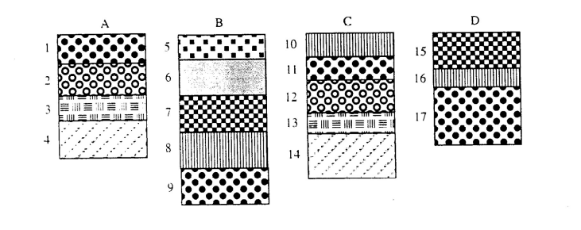
Which of the following statements is INCORRECT regarding the above strata?

a) A1 is the same age as B9.
b) D15 is older than B6.
c) A4 is the same age as C14.
d) B8 is younger than D15.

19. Both genetic drift and natural selection can alter the frequency of alleles in a population. One difference between these agents of change is that

a) the changes caused by genetic drift may not be adaptive.
b) natural selection has more effect in smaller populations and genetic drift in larger ones.
c) genetic drift acts on populations while natural selection acts on individuals.
d) natural selection may be random whereas genetic drift is directional.

20. The techniques that are used to join together genes from different sources in a test tube and to insert foreign DNA into an organism's genome are collectively called

a) recombinant DNA techniques
b) gene cloning techniques
c) gene therapy
d) trans-species recombining
21. Use the following diagram to answer the question below.
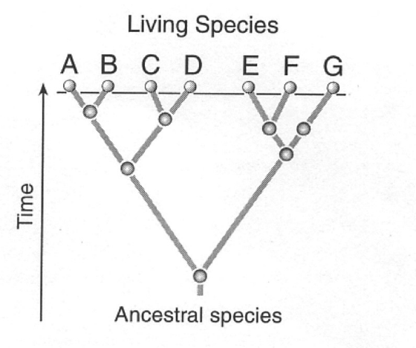
Which two species are likely to have the most similar DNA base sequences?
a) B and G.
b) E and G.
c) C and D.
d) B and C.

Questions 22 and 23 refer to the diagram below
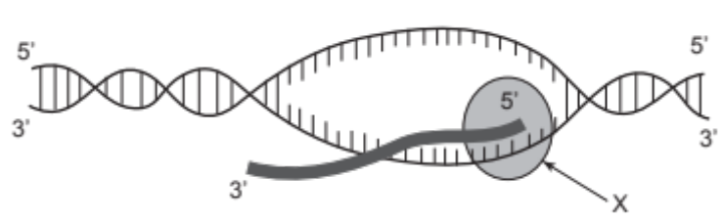

22. The diagram is most likely to be of
a) translation.
b) transcription.
c) gene regulation.
d) DNA replication.

23. The molecule labelled X represents
a) ligase.
b) a ribosome.
c) RNA polymerase.
d) DNA polymerase.

24. What is the promotor region?
a) It is a region of a parent DNA strand that binds to the RNA polymerase and initiates transcription.
b) It is responsible for the selective nature of transcription.
c) It is a region of RNA that binds to the RNA polymerase and initiates transcription.
d) It is a component of each type of RNA.

25. The mRNA codons of amino acids in a sequence of part of a polypeptide chain are shown below. UGU-GAU-CAC-UAG-GAU-AAG-CAC. Which DNA base sequence could provide the code for this section of polypeptide?

a) ACA-CTA-GTG-ATC-CTA-TTC-GTG
b) ACA-CTA-GTG-ATG-CTA-AAC-GTG
c) ACA-CTT-GTG-ATG-CTA-TTC-GTG
d) ACA-CUA-GUG-AUG-CUA-UUC-GUG
26. A single hair is found at the scene of a crime. Which technology would you use first to determine if the hair could have come from a certain suspect?
a) Electrophoresis
b) PCR
c) DNA sequencing
d) DNA fingerprinting

27. Two hominins skull fragments were found in separate locations and each was associated with a number of artefacts. Skull X was dated and shown to be 100,000 years old, while skull Y was dated at 20 000 years old.
The artefacts most likely discovered with skull Y but not skull X would be:

a) fireplace fragments.
b) stone tools for cutting.
c) pigment used in rock paintings.
d) bones from hunted animals.

28. A fossil was found of a primate. Which piece of evidence would be useful in determining whether it was an ape or an early hominin?

a) The fossil had a wide trunk, relative to its body length
b) It had opposable digits
c) It was determined to be approximately 2 and a half million years old
d) Its jaw was parabolic in shape

29. New alleles arise in a sexually reproducing population by:

a) mutations in DNA sequences prior to meiosis.
b) random fertilisation of gametes during reproduction.
c) random assortment of homologous chromosomes during meiosis.
d) exchange of chromatin between homologous chromosomes during meiosis.

30. What is the purpose of the Human Genome Project?

a) to mass produce important sequences of DNA
b) to archive everyone's DNA fingerprint
c) to identify the sequence of human DNA
d) to develop an "ideal" genetic code

END OF SECTION ONE
Section Two: Short answer 50% (100 Marks)

This section has NINE questions. Answer all questions. Write your answers in the space provided.

Spare pages are included at the end of this booklet. They can be used for planning your responses and/or as additional space if required to continue an answer.
  - Planning: If you use the spare pages for planning, indicate this clearly at the top of the page.
  - Continuing an answer: If you need to use the space to continue an answer, indicate in the original answer space where the answer is continued, i.e. give the page number. Fill in the number of the question(s) that you are continuing to answer at the top of the page.

Suggested working time: 90 minutes.

Question 31 8 Marks

A group of students investigated the possible relationship between arm length and height in their Science class. They measured arm span. This is the distance between the fingertips when the arms are held out horizontally from each side of the body. Their results are shown in Figure 1.

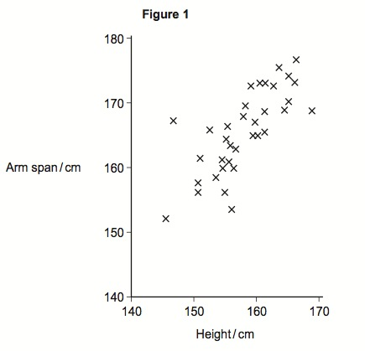

(a) Write a possible hypothesis that could be tested in this experiment.

The taller a person is the longer their arms will be
If a person is tall, then their arms will be long
(2 marks)

(b) What was the dependent variable?

Arm length (do not accept “arms”
(1 mark)

Question 31 (Continued)

(c) Describe what conclusion could be drawn from the data in Figure 1?

tall people have longer arms than short people
(1 mark)

(d) Suggest TWO possible sources of error.

Error in measurement
People may have been measured with shoes on
(Anything 2 reasonable)
(2 marks)

(e) What could be done to test the reliability of the results?

EITHER – repeat experiment again OR repeat with a larger sample size
(1 mark)

(f) Would the data from this experiment form an accurate reflection of the rest of the population? Why/why not?

This only looked at one age group, only used students from one particular socio-economic area
(1 mark)
Question 32 7 Marks

Figure 2 shows the structure of a plasma membrane.
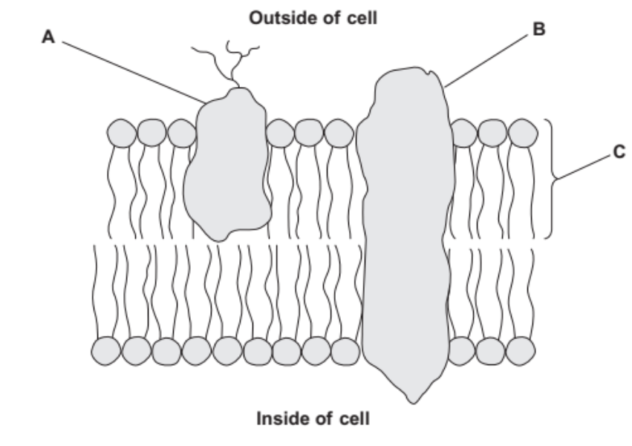
Figure 2

(a) Name:
(i) Protein A receptor protein
(ii) Protein B channel protein/carrier protein
(iii) Molecule C phospholipid
(3 marks)
(b) What are two possible functions of Protein B?

Allow facilitated diffusion
Allow active transport
Allow passage of water (osmosis), ions/ large molecules
(2 marks)

(c) Describe two differences between active transport and facilitated diffusion.

1. Active transport requires energy – facilited diffusion does not
AT moves certain ions, FD does not.
(1 mark)

2. Active transport moves substance from an area of low to high conc. Facil. Dif. Moves substance from high to low
FOR FULL MARKS – MUST TALK ABOUT BOTH types
(1 mark)
Question 33 9 Marks
- Name and describe two (2) types of mutations that can occur in cells?

Gene mutations (point mutations, substitution) – changes in DNA of a single gene – traits are changed or destroyed
Chrmosomal mutations – all or part of chromosome is affected
Somatic mutation – affects body cells – mutation not passed on
Germline mutations – gamete DNA affected – can be passed on

ANY TWO with description
(4 marks)
- In terms of protein synthesis, what would be two (2) possible effects resulting from a mutation?
A STOP codon might be formed – so protein is only half complete.
The wrong protein might be made

no affect - neutral
ANY TWO
(2 marks)

(c) Once a polypeptide (small protein) has been formed, describe the events that allow the polypeptide to be moved out of the cell.

The protein is surrounded by the cell membrane forming a vesicle.
The vesicle then expels the contents (protein) outside of the cell (exocytosis)
Golgi apparatus/Endoplasmic reticulum/ protein modification
MUST MENTION VESICLE – MUST EXPLAIN EXOCYTOSIS
(3 marks)

Question 34 16 Marks

(a) (i) What is epigenetics?

The control of gene expression via accessibility to DNA coding regions for transcription
Change to histones – DNA does NOT change (MUST)
MUST MENTION GENE EXPRESSION
(2 marks)

Explain the roles of methylation and acetylation in epigenetics.
- Methylation

methyl groups attach themselves to DNA – prevents gene expression (transcription →)
The prevents coding region from being read.

(2 marks)
- Acetylation

if histones have acetyl groups attached – DNA does not coil so tightly around histones – allowing access to coding region for transcription.
(2 marks)

(b) What are ‘gene probes’ and during which procedure would they be used?

Fluorescent markers specific to a DNA region.
Electrophoresis (technically Southern Blot)
Identification of specific genes/diseases
(3 marks)
Question 34 (Continued)
(c) Enzymes are extensively used in molecular biology. Below are the recognition sites of two of two enzymes: BamHI and BclI.
BamHI, cleaves after the first G. BclI cleaves after the first T
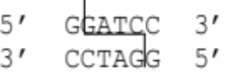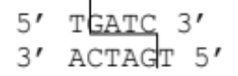
(i) What is the name given to these types of enzymes?
Restriction enzymes
(1 mark)
(ii) In two words, describe what the fragments have been left with after being cut.
Sticky ends
(1 mark)

(iii) If this DNA was cut with BamHI, how many DNA fragment would you expect? Draw in the placement of the cut(s) on the diagram below.
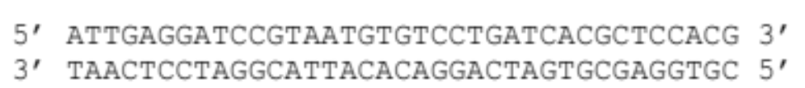

(1 mark)
(iv) If the DNA shown below was cut with BclI, how many DNA fragment would you expect? Draw in the placement of the cut(s) on the diagram below.
(1 mark)
(d) What are coding and non-coding DNA, and what are their scientific names?

Coding- exons – sequence of nucleotide bases that code for a protein – translated into proteins
Non-coding – introns – sequence of bases that do not code for anything – removed after transcription
DO NOT accept “junk DNA” without explanation
(3 marks)
Question 35 10 Marks

The data in the table below shows the radioactive decay of carbon 14 (C14).

Percentage of Original Radioactivity (%) | Time (Years)
100 | 0
54 | 5000
29 | 10000
16 | 15000
8 | 20000
5 | 25000
2 | 30000
1 | 35000

(a) Graph the data on the grid below.
(4 marks)

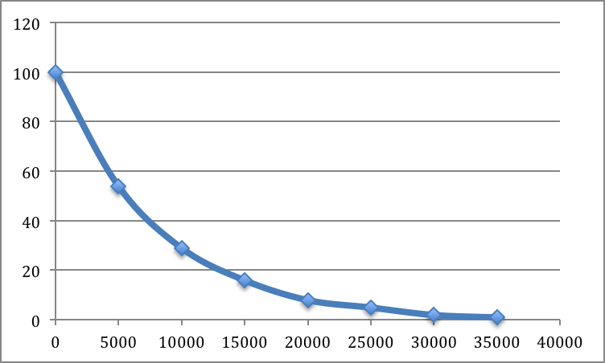

1 – title
1 – labels
1 – neat
1 - good/correct scale
Question 35 (Continued)

(b) A fossil was found to contain 18% of its original radioactivity.

Use the graph to determine the age of the fossil? Accept 13,000 – 14,000 YEARS
(1 mark)

(c) What is meant by the term ‘half-life of an isotope’?

It is the length of time it takes for 50% of the unstable atoms to change into a stable atom
(1 mark)

(d) The following items were found in a cave:
- carefully constructed stone tools
- ash from an ancient fire hearth (dated at 30,000 years old)
- hominin bones
- mural art on the walls

(i) Which of the above evidence of early life is a fossil? Explain why.

C- the hominin bones
They are the preserved remains of an organism that once lived
(2 marks)

(ii) Which of the above evidence of early life is an artefact? Explain why.

A, B, and D – they are remains that have been created by that organism.
(2 marks)
Question 36 14 Marks

(a) List the following skulls from the oldest to the most recent.

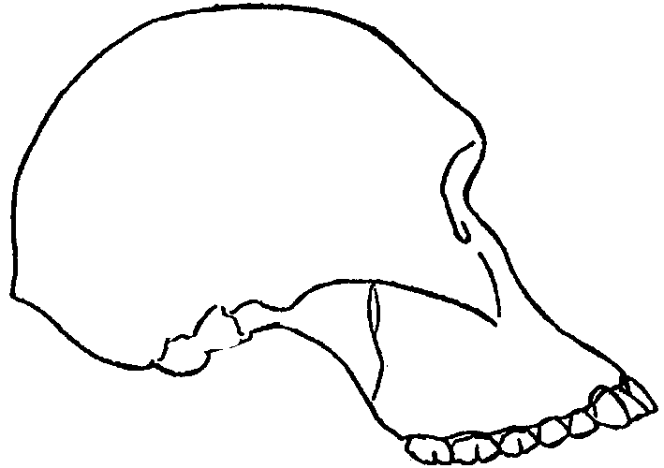
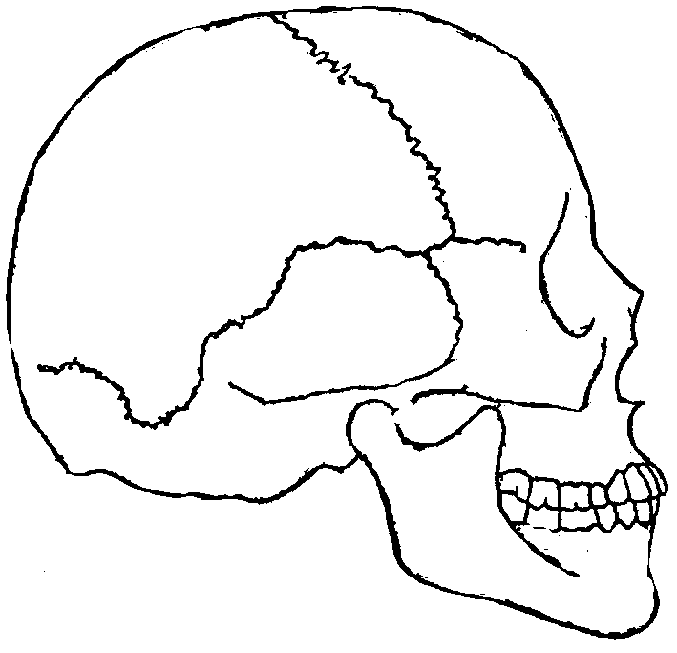
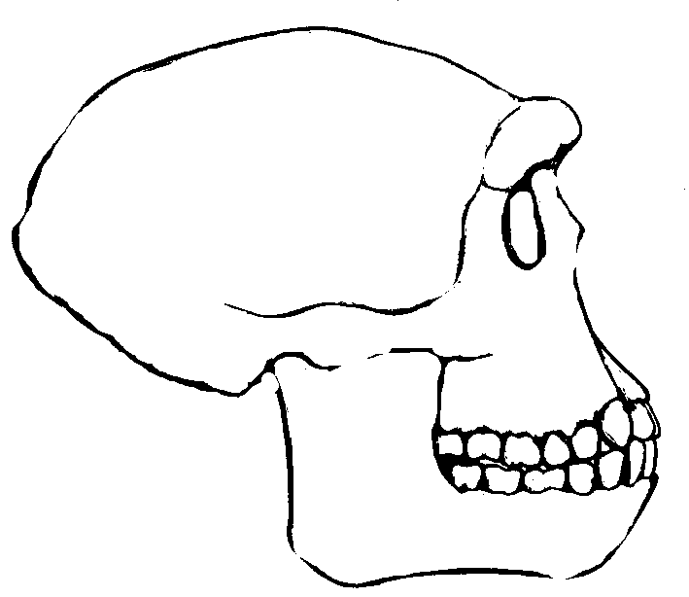
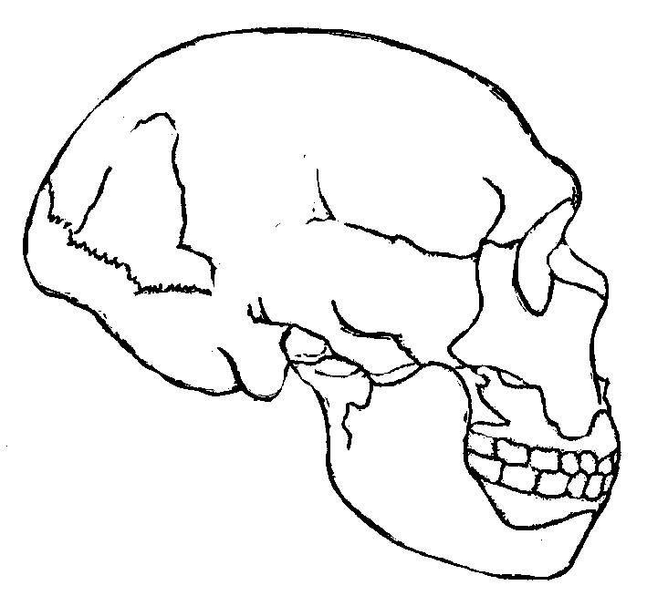
Skull B
Skull A
Skull C
Skull D

Oldest A

D

C

Most recent B

(2 marks)

(b) Describe and explain TWO adaptations primates have that make them suited to arboreal life?

Long fingers - grabbing/swining on branches
Finger ridges – gripping branches
Longer arm to leg ratio – better for swinging through trees.
Stereoscopic vision – ability to judge distances
Circumduction of shoulder (brachiation) swinging through trees
DID NOT ACCEPT: - any reason that was not related to arboreal life
Many thought this referred to humans
(4 marks)

Question 36 (Continued)

(c) Identify THREE evolutionary changes that are present when the human skull is compared to the other hominid skulls below. Suggest ONE reason for each change.
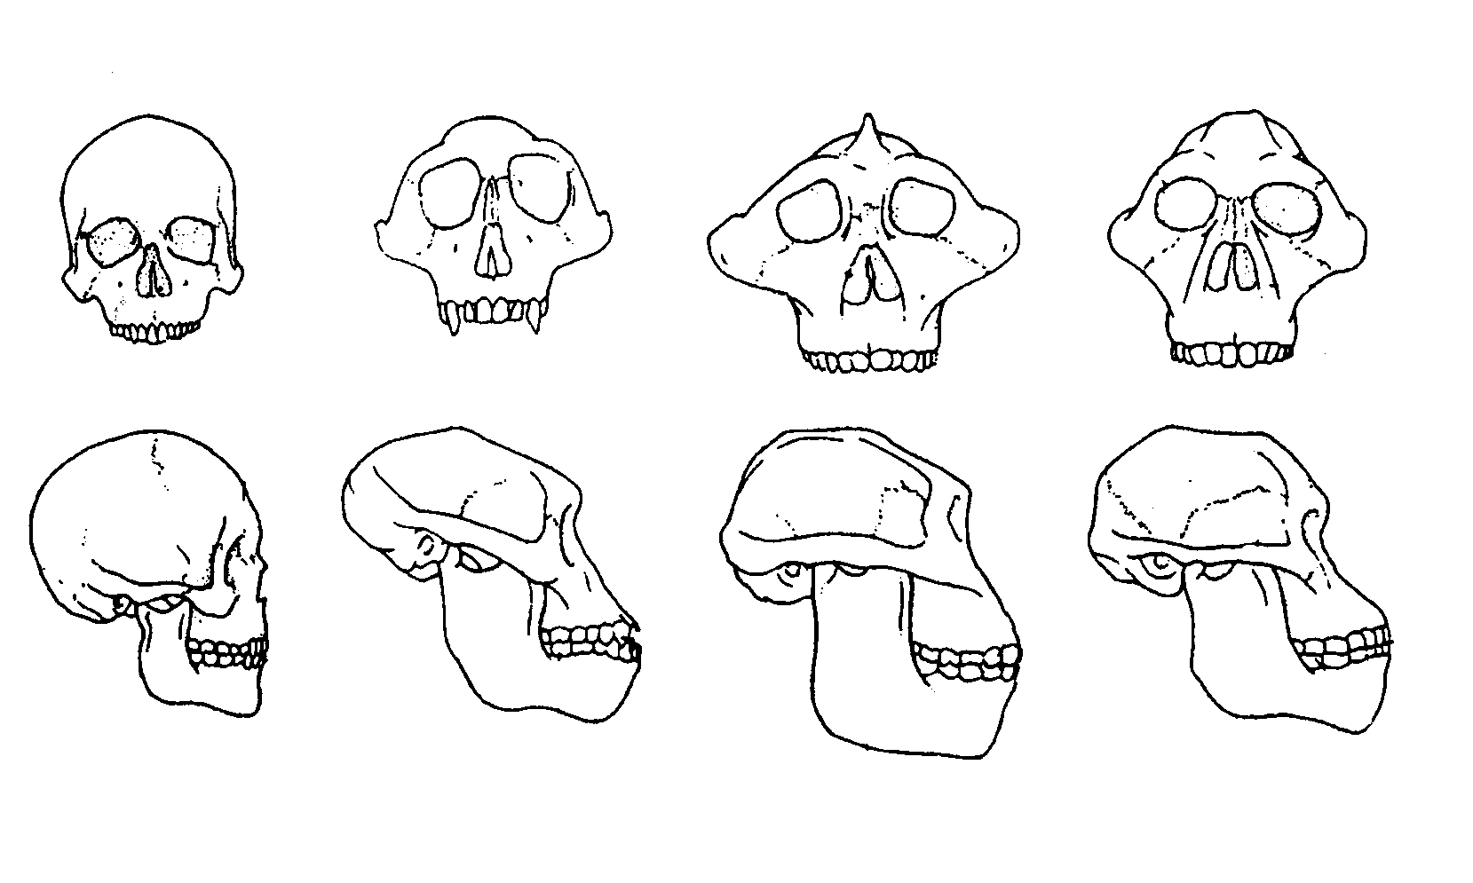
EVOLUTIONARY CHANGE | REASON
Reduction in teeth size | Diet changed – no longer needed from grinding – more suited to biting and tearing
reduced prognathism | diet change – reduction in olfactory sense – less surface area needed
Cranial capacity increased | Accommodate a larger brain
foramen magnum | has become more central at the base of the skull – provides better centre of gravity for upright stance and bipedalism
Reduction in size of jaw | Diet change – to softer foods – do not need large jaw and muscles to grind food
DID NOT ACCEPT “increased brain capacity” – question asks for skull changes.
- I would warn against using ‘teeth’ as a change in skull features
A ‘flatter face/less prognathism’ was NOT DUE to bipedalism
(6 marks)

(d) What was the selective pressure that selected for an upright stance and bipedalism? Describe its importance in developing an upright stance in hominids

Change in environment – drier – less trees – more grassland
Had to come to ground to find food – upright stance help them see food and predators
Carrying items, speed
(2 marks)
Question 37 14 Marks

(a) What is meant by the term ‘gene pool’?

All the possible genes in a particular population.
MUST USE “POPULATION”
(1 mark)

Blood types are a multi-allele trait. The three alleles are: A, B and O, and are represented in Table 1 as I^{A}, I^{B} and i respectively. Table 1 compares allele frequency across two populations. The following two questions refer to the table below.

Table 1.
Frequency of blood alleles in two populations

Allele | Population A | Population B
I^{A} | 30% | 10%
I^{B} | 5% | 0%
i | 65% | 90%

(b) Explain how differences in allele frequencies of blood groups could arise.

Random genetic drift – small population, isolated – less gene flow – increased chance of certain triats increasing (or decreasing) in frequncy for no reason.
MUST EXPLAIN RDG + any two points
Mutation – not accepted
Accepted interbreeding
(3 marks)

(c) What would you expect to happen to the frequencies of these alleles, if Population A bred with Population B?

I^{B} frequency would increase as dominant to i
similar trend with I^{A} and
i would decrease
ANY ONE – ideally should refer to one of the populations
(1 mark)

(d) What is the genetic term given to this process?

Gene flow (do not accept migration)
(1 mark)
Question 37 (Continued)
(e) Variations in skin pigmentation (‘skin colour’) are coded for by polygenic inheritance.
(i) What is polygenic inheritance?

A trait that is influenced by many genes.
NOT ‘alleles’ – unless phrased as “many pairs of alleles”
“multiple-allele”’ is s separate type of inheritance
(1 mark)
(ii) How have variations in skin pigmentation been advantageous in particular environments?

In climates receiving lots of sun –increased pigmentation also provide filter for UV – protect against skin cancer, also radiates heat to keep cool,
In colder climates – less sun – less pigmentation – let UV in to increase Vit D production

Needed to emphasis “sunlight/UV’ – heat not relevant unless saying dark skin radiates heat more –therefore heat loss
(2 marks)
(iii) Given another example of a polygenic inherited trait in humans.
Intelligence, height, weight,
ACCEPTED hair/eye colour – but not a good example
(1 mark)

(f) General practitioners (doctors) are being urged not to over prescribe antibiotics as this can cause the development of ‘super-bacteria’. Explain how natural selection causes a population of antibiotic resistant bacteria to develop and why this occurs more frequently where communities take the antibiotics for less than the recommended time period.

- variation within bacterial population
- bacteria reproduce quickly
- if not all bacteria are killed – bacteria reproduce
- bacteria can mutate
- mutation could mean it becomes resistant
- pass on resistance
(any 4)
MUST GET THE ORDER OF EVENTS CORRECT:
(not all killed – THEN mutate - )
(4 marks)
Question 38 10 Marks

Evidence from fossil skeletons makes scientists believe that approximately 100 000 years ago Homo sapiens, Homo neanderthalensis and Homo erectus were all alive on Earth. By about 30 000 years ago, only Homo sapiens survived. The Out of Africa hypothesis and the Multi-regionalism hypothesis try to explain how Homo sapiens evolved and replaced other hominid species.
The Out of Africa hypothesis suggests that Homo sapiens evolved in Africa and then spread around the world. It also suggests that more than a million years earlier, populations of Homo erectus had spread out of Africa. These populations became geographically isolated and evolved into new species such as Homo neanderthalensis. As Homo sapiens spread, they caused the extinction of all the other hominid species.
The Multi-regionalism hypothesis suggests that populations of Homo erectus evolved into Homo sapiens in many places. According to this hypothesis, all people today are descendants of populations of Homo erectus that spread from Africa about two million years ago. The hypothesis suggests that there was enough interbreeding between different populations to prevent them becoming different species. At the same time, 15 natural selection did cause enough variation between populations to produce the races of people seen today.

(a) The Out of Africa hypothesis suggests that geographic isolation of populations of Homo erectus could have resulted in the evolution of new species such as Homo neanderthalensis.
Explain how the geographic isolation of a population of (such as Homo erectus) could have resulted in the evolution of new species.
No interbreeding between the two populations / no gene/allele flow;
Different environment for each population / suitable named example;
Different selection factors/pressures;
Example of, e.g. different predators/diseases/food organisms;
(Genetic) variation in each population;
Caused by mutation;
Some individuals have selective advantage/better adapted;
Differential survival/some more likely to survive;
To reproduce to pass their alleles to next generation;
Change in alleles/genes/gene pools/allele frequencies/phenotype frequencies;
If reproductive isolation, then new species;
ANY 4 POINTS
(4 marks)
Question 38 (Continued)

(b) The Multi-regionalism hypothesis suggests that interbreeding between different populations of Homo erectus prevented them from becoming different species.
Explain why interbreeding would prevent new species forming.

Interbreeding (between populations) tranfers/carries alleles from one population to another;
Do not become reproductively isolated;

(2 mark)

(c) The Multi-regionalism hypothesis suggests that natural selection caused enough variation between populations to produce the races of people seen today (lines 15 to 17). Some of these races evolved in cold climates where there was little sunshine. Suggest two adaptations of body form that these races may have evolved.
Explain ONE benefit to individuals of each adaptation.

Adaptation: Low surface area to volume ratio/short, round body;
Benefit: | Allows less heat loss;
Epicanthic fold – extra layer of fat
Insulates the eye, helps shield light reflecting off ice

Adaptation: | Light skin colour;
Benefit: | Allows more light to enter skin for vitamin D synthesis/prevents rickets;
(4 marks)
Question 39 12 Marks

(a) Compare TWO ways in which the two different types of stem cells differ.

Embryonic (pluripotent) – cells taken from inner cell mass of human embryos at 4-5 days old
No differentiation
Adult stem cells (Multopotent) – cells found in umbilical cord, placenta, skin, bone marrow
Limited application only certain differentiations are possible.
Avoid using somatic cells or gametes
(4 marks)

(b) What are TWO characteristics of stem cells that distinguish them from other cells?

1. not specialised for any task (undifferentiated)
2. Capable of dividing repeated (mitosis)
3. Are ABLE to specialised (become differentiated)
ANY TWO
characteristics ie PHYSICAL – NOT location
(2 marks)

(c) Compare gene therapy and cell replacement therapy in the table below

 | Gene Therapy | Cell Replacement Therapy/  Tissue Engineering
Aim of therapy | Replace faulty genes with healthy ones | Grow tissue for implantation/replacement
How it would work | Vector is used to insert healthy gene into target cells DNA. | Use persons own cells (or donor) to grow tissue, with help of matrix /scaffold and replace damaged tissue
Ailments that could be treated | Cytstic fibrosis  Huntington’s  Sickel cell anaemia  Parkinsons | Skin burns  Heart defects  Cornea  Repair bone and cartilage  Parkinsons, and Alzeimer’s
(6 marks)
Section Three: Extended answer 20% (40 Marks)
This section has THREE (3) questions. You must answer TWO (2) questions. Write your answers in the lined pages provided.
Spare pages are included at the end of this booklet. They can be used for planning your responses and/or as additional space if required to continue an answer.
● Planning: If you use the spare page for planning, indicate this clearly at the top of the page.
● Continuing an answer: If you need to use the space to continue an answer, indicate in the original answer space where the answer is continued, i.e. give the page number. Fill in the number of the question(s) that you are continuing to answer at the top of the page. Responses may include clearly labelled diagrams with explanatory notes; lists of points with linking sentences; clearly labelled tables and graphs; and annotated flow diagrams with introductory notes.
Suggested working time: 50 minutes
________________________________________________________________________
Question 40 20 Marks

A researcher has isolated a sample of DNA to study. The diagram below shows the segment of DNA of interest with a total length of 4,900 base pairs. The arrows indicate reaction sites for two restriction enzymes (enzyme X and enzyme Y).
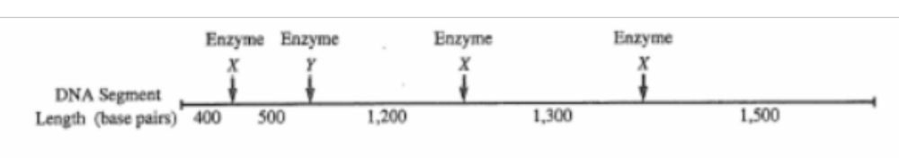

(a) Name and explain the procedure the researcher would have used to make enough of the sample in order to conduct further experiments.

Polymerase Chain Reaction
DNA is heated to 95°C
DNA separates (denatures)
Primers introduced
Nucleotides
Primers are specific to the region to be amplified
Primers help separate DNA strands
Cooled to 55°
TAQ polymerase introduced
Heat to 72°
TAQ polymerase makes copy of the DNA strands
25-40 cycles needed

ANY 7 IN ORDER + NAMING PCR

(8 marks)

(b) Explain the scientific principles and procedures of gel electrophoresis that allow for the separation of DNA fragments.

Electrophoresis tank contains gelatine-like structure
Gel has pores which trap DNA
DNA injected into wells in the gel
A ladder is used to measure the length of the DNA segments
Electric current passed thru the gel - Moves from negative pole to positive.
DNA is negatively charged (attracted to positive end) – gets pulled by current
Larger DNA gets trapped soon
Smaller DNA travels further
ANY SIX
(6 marks)

(c) Describe and explain the results you would expect from the electrophoretic separation of fragments from the following treatments of the DNA segment above.
Scenario 1 DNA digested with only enzyme X
Scenario 2 DNA digested with only enzyme Y
Scenario 3 DNA digested with enzyme X and enzyme Y combined
(6 marks)

Scenario 1: three cuts are made in the DNA (four segments made)
The first segment will travel further – it only has 450bp

Scenario 2: only one cut (2 segments)
The first segment ~1000 bp will travel further than the second segment

Scenario 3: four cuts will be made (5 segments)
Enzyme X will make cut at the first point same as Scenario 1, and will travel furtherest

FOR EACH SCENARIO – MUST MENTION THE AMOUNT OF CUTS/SEGMENTS (1)
AND
SOME DESCRIPTION OF DISTANCE TRAVELLED AND WHY (1)
ACCEPT DESCRPTON OF LENGHS IN GEL ORDER
Question 41 20 Marks

(a) A researcher has the following samples of four species, all of which are vertebrates, and some of which are extinct:

- femurs (thigh bones)
- preserved tissue samples
- preserved embryos

The researcher believes that the four species are all related.

Explain how the researcher might use these samples as evidence of evolution
(6 marks)
ONE MARK FOR NAMING THE PROCEDURE
femurs – comparative anatomy/homologous structure (1)
tissue – comparative DNA (1)
embryos – comparative embryology(1)

ONE MARK FOR EXPLAINING THE PROCEDURE
Homologous structures – compare structures most complex – newest, similarities suggest common ancestor

Comparative DNAprotein sequence – similar DNA/protein base sequences suggest a common ancestor – the greater the similarity – the more recent the ancestor

Comparative embryolgy –all vertebrates originated from fish – so have similar structures as embryos – suggesting common ancestor

(b) DNA is the blueprint that tells the body’s cells what to make and how. A portion DNA consists of the following sequence of nucleotide triplets.
TAC GAA CTT GGG TCC
This DNA sequence codes for the following short polypeptide (very small protein).
methionine - leucine - glutamic acid - proline - arginine
Describe the steps in the synthesis of this polypeptide. Begin your response by assuming the DNA strands are already separated.

RNA polymerase attaches to the template strand of the DNA
RNA polymerase creates messenger RNA strand - mRNA made from nucleotide bases
START and STOP codons
Uses base-paring rules – substituting uracil for thymine
Introns removed
mRNA travels to ribosome
transfer RNA brings amino acids to mRNA
tRNA anti-codons pair up with the codons of the mRNA
amino acids bond, and tRNA molecule is released
ANY EIGHT IN CORRECT ORDER
(8 marks)

(c) Gene expression is controlled at a number of different levels:
(i) at the environment level
(ii) at the cell membrane receptor level
(iii) at the promoter gene level

Describe how gene expression may occur at each of these levels
(6 marks)
The environment
- thru diet, chemicals can block or allow gene expression (1 mark for example)
- this can cause acetylation of histones allow them to loosen coil of DNA allowing transcription etc
- methylation of DNA – blocks gene from being transcribed
- UV and skin pigmentation → transcription for melanin

Cell receptor
- hormones bind to receptors on cell surface
- hormones activate transcription

Promoter level
- transcription factors bind RNA polymerase to the promoter gene on the DNA
- interactions b/n the transcription factors can turn transcription on or off
- regulator genes – allow or prevent binding to gene site

ANY TWO FOR EACH

Question 42 20 Marks

(a) How is the principle of radioactive decay used when dating fossils?
In your answer, refer to a commonly used isotope, and state any limitations of its use.

Describe principle of radioactive decay (2)
- isotopes emit radiation/are unstable atoms
- have a half-life – the time it takes half of the atoms to decay to a stale atom
- isotopes decay at a constant rate MAX 2
COMMON TO BOTH

C-14 (1)
- C-14 decays to Nitrogen (1)
- Enters via food chain/atmosphere – stops at death (1)
- Ratio of C-12:C-14 left in fossil is measured (1)
- C-14 has a half-life of 5730 years
- By measuring how much C-14 is left can determine age MAX 2

Limitations
- only be used on organic structures (1)
- only measure as far back as 70,000 years (1) MAX 2

OR
K-Ar (1)
- Potassium is normally 39 – but has isotope of 40
- K decays to Ar
- When molten Ar escapes
- Measure mount of Ar to K ratio MAX 2

Limitations-
- only used for rock samples
- must be older than 200,000 yr MAX 2

(6 marks)

(b) Describe four (4) structural features of the human skeleton and explain how each feature allows efficient locomotion.

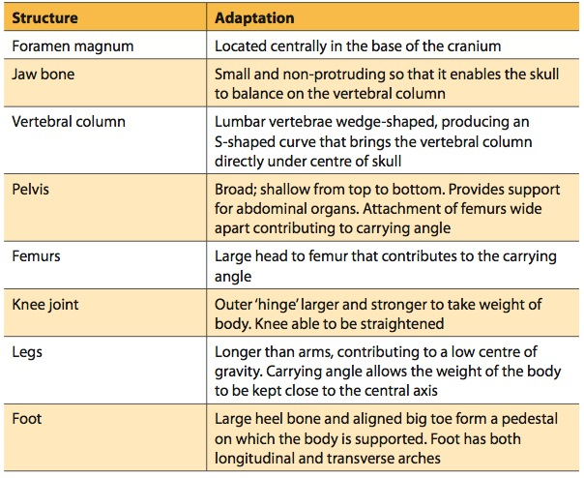
(8 marks)

(c) Hominins not only evolved physically, but also behaviourally and culturally. Identify three (3) of these important changes and explain their significance.

Behaviourally
- longer gestation period
- no longer live in trees
- fire/cooking food/food pre
- crops

Culturally
- engage in agriculture – no longer hunter/gatherers
- diet changed from vegetation to meat
- fire
- art
- tool use
- ceremonies

(6 marks)

END OF EXAM

